**Hot to update AIF document service after table schema modification**

**Created by Massoud Koochak 08/25/2012**

1. **Find out the service depends to the table. E.g. CustCustomerService is depends to CustTable and we want to modify the CustTable.**
2. **Find out the query as a base of service. For our example the query is AxdCustomer.**
3. **Check the data source->fields in query for the table and see if the DYNAMIC property is Yes or No. e.g. AxdCustomer query is the base for CustCustomerService service. In our example CustTable schema has been modified. In below screen we see CustTable in AxdCustomer query has property DYNAMICS set to NO. It means any update to table schema won’t be reflected to query automatically and developer needs to modify the query. But if the property is set to YES we just need to restore the query by right click on it and select restore.**

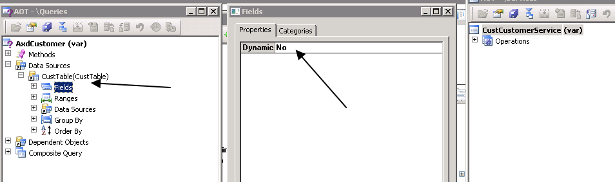

1. **Find related project to the service in projects-> Private** 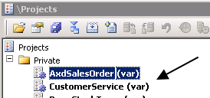

**in our example we work with CustomerService project**

1. **Make a backup of the project by exporting it.**
2. **Now the AIF service needs to be updated. Run AX tools->development tools->Application Integration Framework->update document service.**

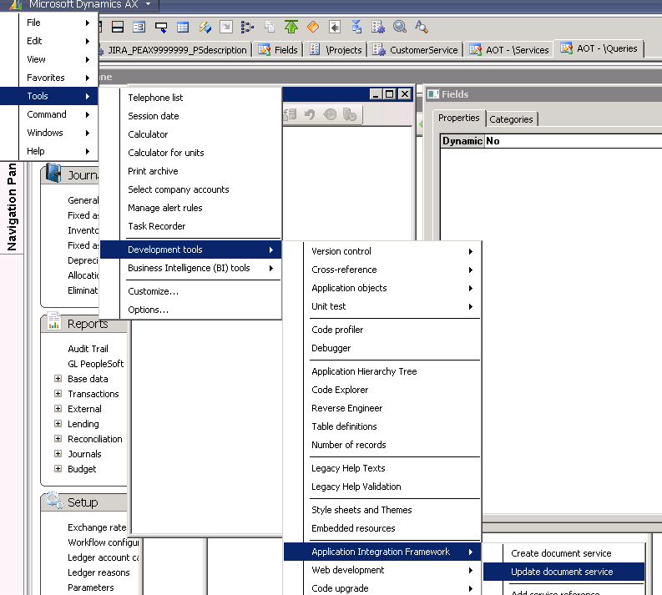

1. **We will have below form:** 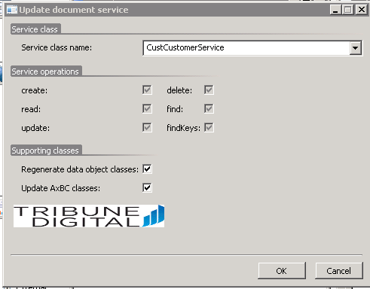 click Ok and it takes few minute to re-generate all AIF objects in AX.
2. **We need to compare the backup XPO file from the project to AX objects after AIF update process to make sure all the customized codes are there. If there is any difference then we need to merge customized code from XPO to the object.**
3. **Run Basic->setup-> Application Integration Framework-> EndPoints and follow the below screen** 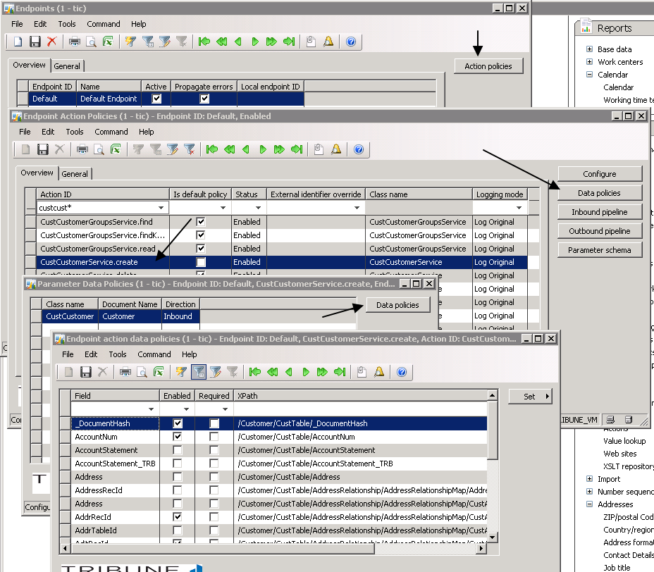
4. **Above example is for CustTable schema modification. Here we need to filter the field we have modified to make sure is in data policy list. Check Enabled/Required check boxes and modify them if they are not correct. If we cannot find the specific/modified field in data policy then we can repeat this step after next step.**
5. **Run IIS manager and find the MicrosoftDynamicsAif50 site(it is same as screen shot in step 13) and explore its file and make a backup for all its IIS file**
6. **Run Basic-> setup -> Application Integration Framework->Services and click Generate button (If a new service is added we need to click Refresh button first).**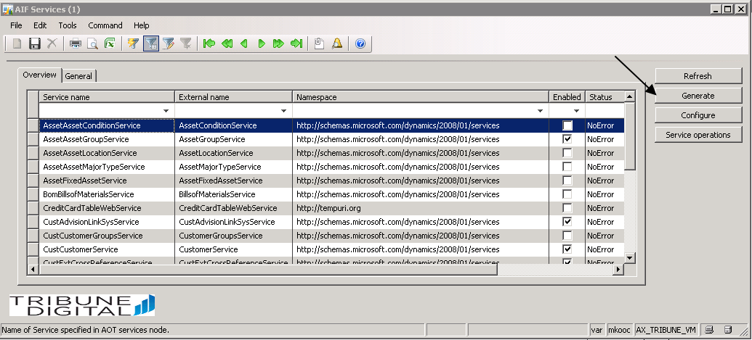
7. **It will generate all IIS files in IIS (Below screen is from my AX VM)**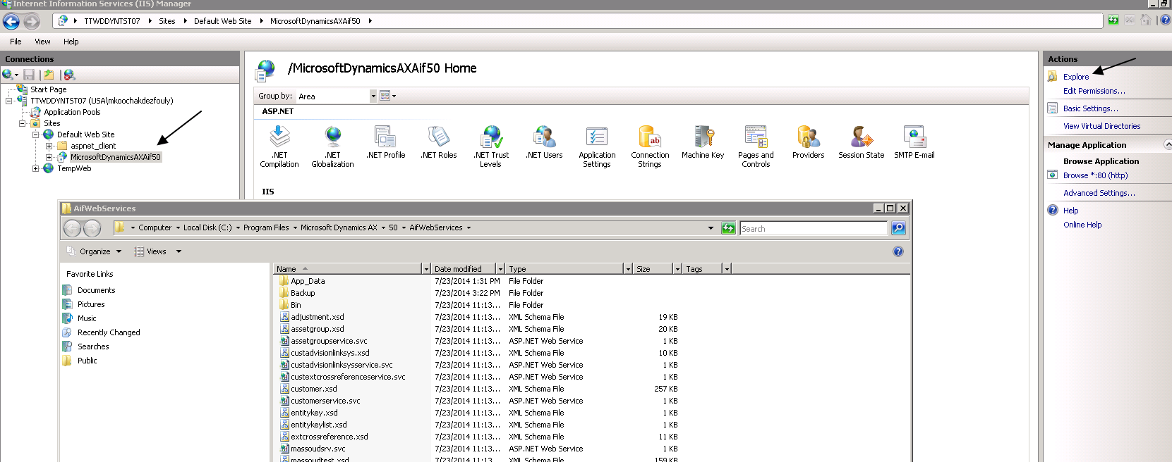
8. **Compare the new web.config file with the backup one(created in step 11) and if they are not same replace web.config file by backup file**
9. **Restart IIS**
10. **For this example we need to open Customer.xsd file to see the table schema modification is there or not. If Customer.xsd file is not correct back to AX and in AX AOT find the 2 below classes and run them(sequence is not important) and start from step# 7**

